Experiment #1 - Clock and Periodic Signal Generation

Ali Keramati,

810198519

1. Clock Generation Using ICs and Analog Components
2. *Ring Oscillator*

As shown in Figure 2, propagation delay will be: $0.18μs=10 × Delay$

Due to the equation we have Delay = 18ns

1. *LM555 Timer*

Duty cycle and clock frequency can be calculated as below:

$$duty cycle= \frac{1+50}{1+100}=0.504950495$$

$$clock frequency=\frac{1}{T}=\frac{1}{0.693\left(1+100\right){10}^{-5}}=1428.7143000014$$

if $R2=1kΩ$:

$$duty cycle=\frac{2}{3}$$

$$clock frequency=\frac{1}{0.693\left(1+2\right){10}^{-5}}=48100.048100048$$

if $R2=10kΩ:$

$$duty cycle=\frac{11}{21}=0.5238095238$$

$$clock frequency=\frac{1}{0.693\left(1+20\right){10}^{-5}}=6871.435442864$$

if $R2=100kΩ:$

$$duty cycle=\frac{101}{201}=0.50224875622$$

$$clock frequency=\frac{1}{0.693\left(1+200\right){10}^{-5}}=717.9111656724$$

1. Schmitt Trigger Oscillator

If R = 470 $Ω$ then

$$α=470×{10×10}^{-9}×276808=1.301$$

If R = 1k $Ω$ then

$$α=1000×{10×10}^{-9}×137888=1.378$$

If R = 2.2 $Ω$ then

$$α=2200×{10×10}^{-9}×64545=1.42$$

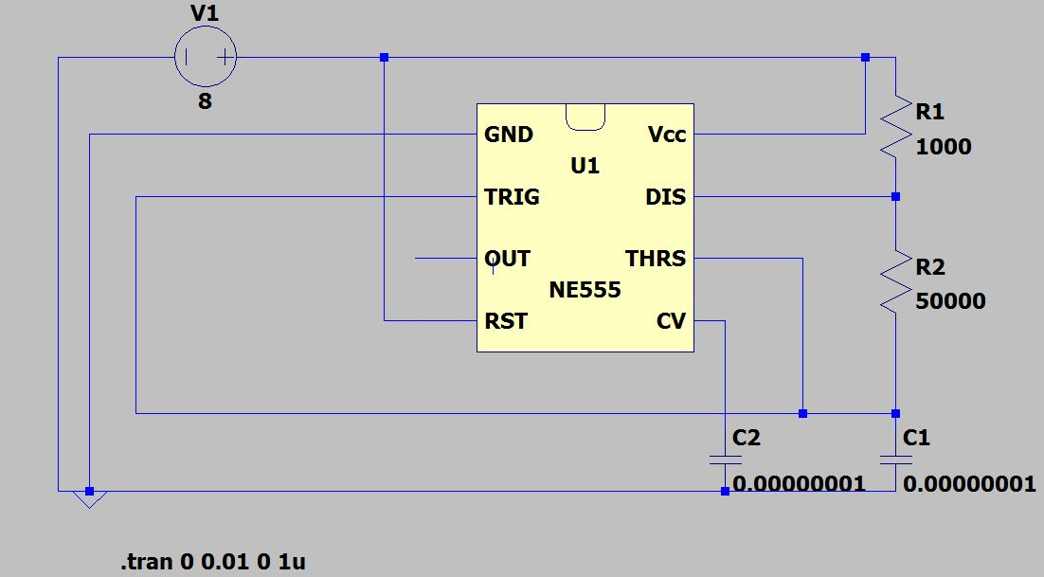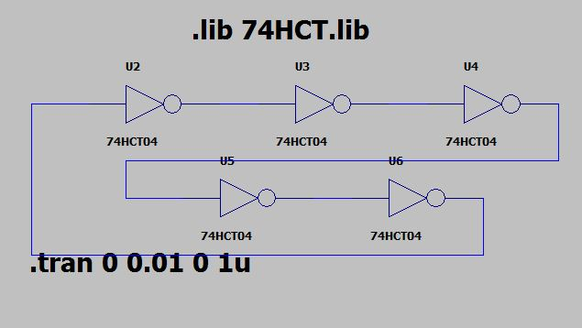

Figure 3

Figure 1

Figure 2

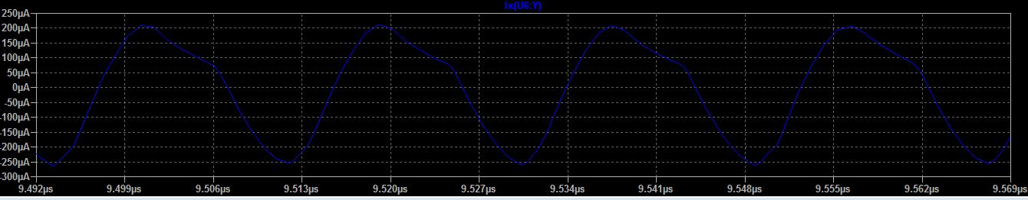

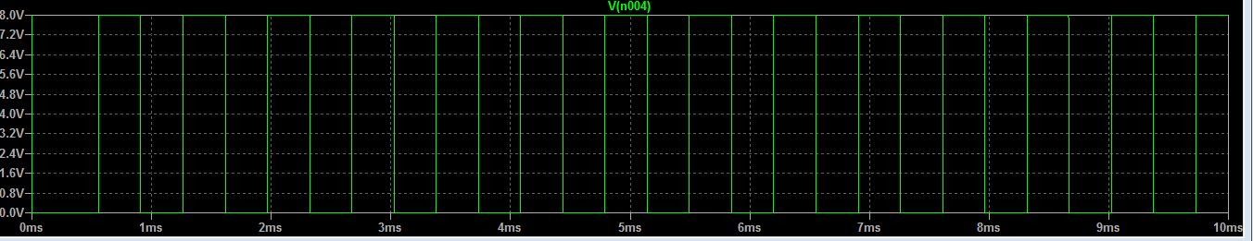

1. FPGA Design
2. *Ring Oscillator*

Waveform shown in Figure 4.

1. *Synchronous Counter as a Frequency Divider*

Due to Figure 5, we can see the mechanism

1. T Flip-Flop

T Flip-Flop is beside Frequency Divider in Figure 5.

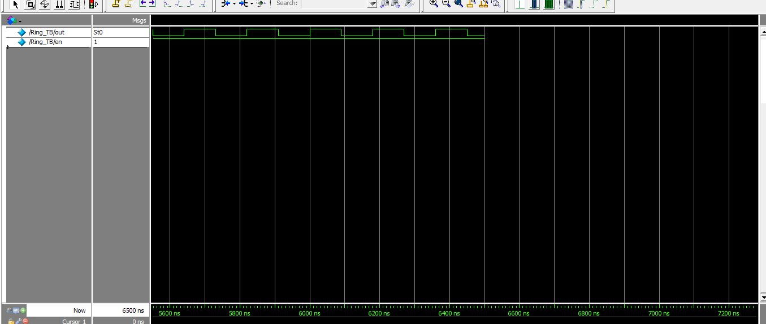

Figure 4

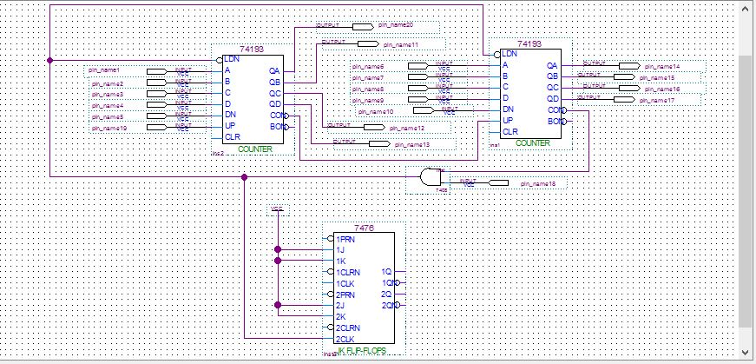

Figure 5